Name : Khushi Panwar

SEC (Python) PRACTICAL ASSIGNEMENT : 08.09.2022

Computer Science (3rd Sem)

**Question 4 (From Practical List ) : Write a function that takes a number (>=10) as an input and return the digits of the number as a set**

**Solution →**

def createSet():

num=input("\nEnter the number here : ")

lst=[int(x) for x in str(num)]

if (float(num)>=10):

setDigit=set()

for i in lst:

setDigit.add(i)

return setDigit

else:

print(" ERROR : INVALID NUMBER ! Try again ")

creatSet()

result=createSet()

print()

print("-> The Set Formed : ", result)

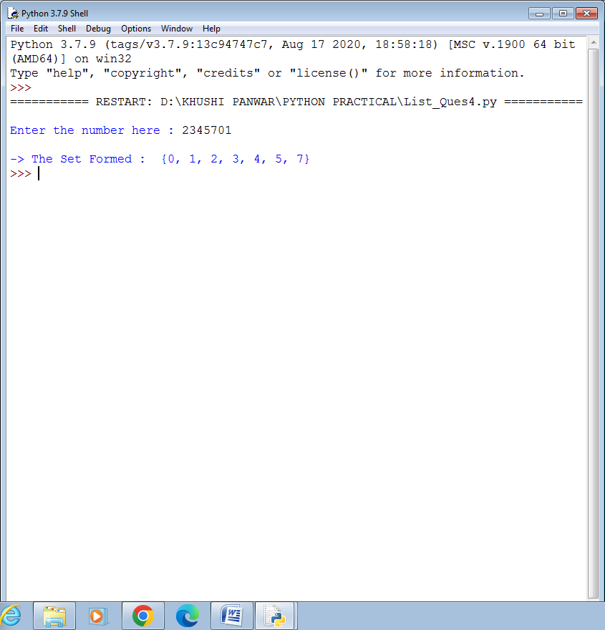

**Question 5 (From Practical List ) : Write a function that finds the sum of the n terms of the following series. Import the factorial function created in question 3**

**1-x2/2!+x4/4!**

**Solution →**

#list question : program 5

#function that find sum of the n terms of series

print()

print("\n \t Find the sum of n terms of the series \n \t 1-x2/2!+x4/4!-x6/6!+......+ xn/n! \n")

n=int(input("-> Enter the value of n : "))

x=int(input("-> Enter the value of x : "))

from List_Ques3 import factorial as fact

if (n%2==0):

terms=int(n/2)

sum=1

for i in range(terms+1):

t=(((-1)**i)*x*i*2)/fact(i*2)

sum+=t

print("\n Sum of series is : ", sum)

#even values are valid

else:

print("\n !! ERROR : Enter the valid value of n !! ")

